Vehicle Rental and Fleet Management System

Report: Design, Implementation, Testing & Reflection
Course Code & Name: CSA0210 - C Programming
Assignment Title: Vehicle Rental Centre
Course Outcomes Covered: CO3 (searching/sorting/array & string processing), CO4 (structures, nested structures, real-world data modeling), CO5 (modular design - functions, recursion, pointers, file handling)
Bloom's Taxonomy Level: Level 6 - Create / Evaluate

1. Problem Statement Summary
A vehicle rental centre needs to maintain customer and vehicle details, record rental requests, assign rental priorities, track vehicle availability, calculate rental charges, and retrieve previous rental records. This report documents a complete C program - the Vehicle Rental and Fleet Management System (VRMS) - that stores, processes, searches, sorts, updates, and persists rental information end-to-end through a menu-driven console interface.

2. Requirement-to-Design Mapping
Requirement | How VRMS Satisfies It
(a) Structures, nested structures, multidimensional arrays | Customer, Vehicle, Rental structs; Maintenance nested inside Vehicle; Payment nested inside Rental; fleetMatrix[3][2] multidimensional array for type x availability reporting
(b) Functions and pointers for add/update/search/cancel/retrieve | addCustomer, addVehicle, addRentalRequest, updateRental, cancelRental, searchRentalById, findCustomer, findVehicle - all operate on struct pointers, no unnecessary globals
(c) Searching and priority-based sorting | Linear search (rentals, frequently changing), binary search (vehicle catalogue, sorted first), insertion sort by priority then earliest return deadline
(d) File handling for persistence and reload | saveAllToFile()/loadAllFromFile() write and reload customers.dat, vehicles.dat, rentals.dat on every save/exit and on startup

3. Pseudocode

3.1 Data Model
STRUCTURE Maintenance
lastServiceDate, nextServiceDate, condition

STRUCTURE Vehicle
vehicleId, regNo, model, type, ratePerDay, available
maint : Maintenance // nested structure

STRUCTURE Customer
customerId, name, phone, license

STRUCTURE Payment
amount, paid, paymentDate

STRUCTURE Rental
rentalId, customerId, vehicleId
startDate, returnDeadline, priority, status, durationDays
payment : Payment // nested structure

ARRAY customers[MAX], vehicles[MAX], rentals[MAX]
ARRAY fleetMatrix[VEHICLE_TYPES][STATUS_COUNT] // multidimensional

3.2 Core Operations
FUNCTION generateRentalId()
STATIC counter = 1000 // persists across calls, unlike auto
RETURN counter++

FUNCTION addRentalRequest()
READ customerId, vehicleId
c <- findCustomer(customerId); v <- findVehicle(vehicleId)
IF c is NULL OR v is NULL THEN PRINT error, RETURN
IF v.available = FALSE THEN PRINT "unavailable", RETURN
r.rentalId <- generateRentalId()
READ startDate, returnDeadline, priority, durationDays
r.payment.amount <- calculateBill(r, v)
v.available <- FALSE
APPEND r TO rentals[]

FUNCTION searchRentalById(id) // LINEAR SEARCH
FOR each rental in rentals[]
IF rental.rentalId = id THEN RETURN pointer to rental
RETURN NULL

FUNCTION binarySearchByVehicleId(arr, n, key) // BINARY SEARCH
sortVehiclesById(arr, n) // pre-condition: sorted
low <- 0 ; high <- n-1
WHILE low <= high
mid <- (low+high)/2
IF arr[mid].vehicleId = key THEN RETURN mid
ELSE IF arr[mid].vehicleId < key THEN low <- mid+1
ELSE high <- mid-1
RETURN -1

FUNCTION sortRentalsByPriority(arr, n) // INSERTION SORT
FOR i <- 1 TO n-1
key <- arr[i]; j <- i-1
WHILE j >= 0 AND (arr[j].priority < key.priority
OR (arr[j].priority = key.priority
AND arr[j].returnDeadline > key.returnDeadline))
arr[j+1] <- arr[j]; j <- j-1
arr[j+1] <- key

FUNCTION cancelRental()
READ id ; r <- searchRentalById(id)
IF r = NULL THEN PRINT "not found"; RETURN
r.status <- CANCELLED
v <- findVehicle(r.vehicleId); v.available <- TRUE

FUNCTION saveAllToFile() / loadAllFromFile()
FOR each record type (customer, vehicle, rental)
WRITE/READ pipe-delimited line per record to/from .dat file

MAIN
loadAllFromFile()
LOOP
SHOW menu; READ choice
CALL matching operation
UNTIL choice = EXIT
saveAllToFile()

4. Structure & Nested Structure Design
Customer, Vehicle and Rental are kept as three separate top-level structures rather than one bloated record, so each models a single real-world entity. Vehicle-specific service data (last/next service date, condition) is factored into a nested Maintenance structure, and rental-specific billing data (amount, paid flag, payment date) is factored into a nested Payment structure. This avoids duplicating maintenance fields on every rental record and billing fields on every vehicle record, and keeps each struct's fields cohesive.

5. Storage Class Justification - the Rental Counter
generateRentalId() declares its counter as static int counter = 1000; inside the function body. A static local variable is initialised once and then retains its value across every subsequent call, without being visible outside the function (unlike a global variable).
If the counter were declared with automatic storage (the default for a local variable, e.g. plain int counter = 1000;), it would be re-initialised to 1000 on every call to generateRentalId(). Every new rental would then be assigned the same ID (1000), so searchRentalById() and the .dat file would contain duplicate keys - lookups, updates and cancellations would silently operate on the wrong record, and file reloads would corrupt the rental history. static is therefore the correct and justified choice: it gives a unique, strictly increasing ID generator with function-level encapsulation.

6. Searching & Sorting - Alternatives Compared
Two searching strategies and two sorting strategies were evaluated before finalising the design:
Technique | Time Complexity | Space | Why chosen / rejected
Linear search (rentals) | O(n) | O(1) | Chosen: rentals[] changes every transaction (add/cancel/update); re-sorting before every search would cost more than one O(n) scan on this small (<=100) array
Binary search (vehicles) | O(log n) | O(1) | Chosen: vehicle catalogue is read far more often than it changes, so the one-time O(n log n) sort cost is amortised across many fast O(log n) lookups
Insertion sort (priority queue) | O(n) best, O(n^2) worst | O(1), stable, in-place | Chosen: rentals list is small and nearly-sorted between insertions; insertion sort is stable (equal-priority rentals keep FIFO order) which a naive quicksort is not
Bubble sort (rejected alternative) | O(n^2) always, more swaps | O(1) | Rejected: same worst case as insertion sort but consistently more comparisons/swaps in practice - no advantage for this data size
Quicksort (rejected alternative) | O(n log n) avg, O(n^2) worst | O(log n) stack | Rejected: faster asymptotically for large n, but not stable, adds recursion overhead, and rentals[] here stays small enough that the constant-factor / stability trade-off favours insertion sort

Accuracy & resource utilisation: linear + insertion sort keep memory flat (all arrays are fixed-size and stack/global allocated, no dynamic allocation to leak), execution stays well under a millisecond for the tested record counts, and the design scales linearly with MAX; for a production fleet several orders of magnitude larger, binary search's O(log n) advantage and a heap-based priority queue would become the better trade-off - noted here as the scaling boundary of the current design.

7. Complete C Source Code (vrms.c)
Compiled with: gcc -Wall -o vrms vrms.c (0 errors, 0 warnings)
/* ============================================================
VEHICLE RENTAL AND FLEET MANAGEMENT SYSTEM
Course: CSA0210 - C Programming
Assignment: Vehicle Rental Centre
------------------------------------------------------------
Demonstrates: structures, nested structures, multidimensional
arrays, functions & pointers, searching (linear + binary),
priority-based sorting (insertion sort), storage classes
(static counters), and file handling.
============================================================ */

#include <stdio.h>
#include <stdlib.h>
#include <string.h>

#define MAX 100
#define NAME_LEN 40
#define DATE_LEN 12
#define VEHICLE_TYPES 3 /* 0=Car 1=Bike 2=Van */
#define STATUS_COUNT 2 /* 0=Available 1=Rented */

const char *VTYPE_NAMES[VEHICLE_TYPES] = {"Car", "Bike", "Van"};

/* ---------------- STRUCTURES & NESTED STRUCTURES ---------------- */

typedef struct {
char lastServiceDate[DATE_LEN];
char nextServiceDate[DATE_LEN];
char condition[20]; /* Good / Needs Service / Under Repair */
} Maintenance;

typedef struct {
int vehicleId;
char regNo[15];
char model[NAME_LEN];
int type; /* index into VTYPE_NAMES */
float ratePerDay;
int available; /* 1 = available, 0 = rented */
Maintenance maint; /* nested structure */
} Vehicle;

typedef struct {
int customerId;
char name[NAME_LEN];
char phone[15];
char license[15];
} Customer;

typedef struct {
float amount;
int paid; /* 0 = unpaid, 1 = paid */
char paymentDate[DATE_LEN];
} Payment;

typedef struct {
int rentalId;
int customerId;
int vehicleId;
char startDate[DATE_LEN];
char returnDeadline[DATE_LEN];
int priority; /* 1 = urgent, 0 = normal */
int status; /* 0=active, 1=returned, 2=cancelled */
int durationDays;
Payment payment; /* nested structure */
} Rental;

/* ---------------- GLOBAL DATA (arrays hold all records) ---------------- */

Customer customers[MAX];
Vehicle vehicles[MAX];
Rental rentals[MAX];

int customerCount = 0;
int vehicleCount = 0;
int rentalCount = 0;

/* Multidimensional array: fleet status matrix [vehicle type][availability] */
int fleetMatrix[VEHICLE_TYPES][STATUS_COUNT];

/* ---------------- STORAGE CLASS DEMONSTRATION ----------------
A 'static' local variable inside generateRentalId() retains its
value BETWEEN function calls without being tied to a global
variable. If it were declared 'auto' (the default for locals),
it would reset to its initial value on every call, and every
rental would be assigned the same ID (duplicate keys, broken
lookups and file records). 'static' guarantees a strictly
increasing, unique rental ID across the life of the program,
without polluting the global namespace like a global variable
would. This is the justified choice for the service/job counter.
------------------------------------------------------------- */
int generateRentalId(void) {
static int counter = 1000; /* persists across calls */
return counter++;
}

/* ---------------- FUNCTION PROTOTYPES (pointers used for records) ---------------- */
void addCustomer(void);
void addVehicle(void);
void addRentalRequest(void);
Rental* searchRentalById(int id); /* linear search, returns pointer */
int binarySearchByVehicleId(Vehicle arr[], int n, int key); /* binary search */
void sortRentalsByPriority(Rental arr[], int n); /* priority + deadline insertion sort */
void sortVehiclesById(Vehicle arr[], int n); /* required before binary search */
void updateRental(void);
void cancelRental(void);
float calculateBill(Rental *r, Vehicle *v);
void displayAllRentals(void);
void displayFleetMatrix(void);
void saveAllToFile(void);
void loadAllFromFile(void);
Customer* findCustomer(int id);
Vehicle* findVehicle(int id);
void rebuildFleetMatrix(void);
int compareDates(const char *d1, const char *d2);

/* ================================================================
MAIN MENU
================================================================ */
int main(void) {
int choice;
loadAllFromFile();
rebuildFleetMatrix();

do {
printf("\n===== VEHICLE RENTAL & FLEET MANAGEMENT SYSTEM =====\n");
printf("1. Add Customer\n");
printf("2. Add Vehicle\n");
printf("3. Create Rental Request\n");
printf("4. Search Rental by ID\n");
printf("5. Update Rental\n");
printf("6. Cancel Rental\n");
printf("7. Sort & Display Rentals by Priority/Deadline\n");
printf("8. Display Fleet Availability Matrix\n");
printf("9. Binary Search Vehicle by ID\n");
printf("10. Save Records to File\n");
printf("0. Exit\n");
printf("Enter choice: ");
if (scanf("%d", &choice) != 1) { while(getchar()!='\n'); choice = -1; }

switch (choice) {
case 1: addCustomer(); break;
case 2: addVehicle(); break;
case 3: addRentalRequest(); break;
case 4: {
int id; printf("Enter Rental ID: "); scanf("%d", &id);
Rental *r = searchRentalById(id);
if (r) printf("Found -> Customer:%d Vehicle:%d Priority:%s Status:%d Deadline:%s\n",
r->customerId, r->vehicleId, r->priority ? "URGENT" : "Normal",
r->status, r->returnDeadline);
else printf("Rental ID not found.\n");
break;
}
case 5: updateRental(); break;
case 6: cancelRental(); break;
case 7: sortRentalsByPriority(rentals, rentalCount); displayAllRentals(); break;
case 8: displayFleetMatrix(); break;
case 9: {
int id; printf("Enter Vehicle ID to search: "); scanf("%d", &id);
sortVehiclesById(vehicles, vehicleCount);
int idx = binarySearchByVehicleId(vehicles, vehicleCount, id);
if (idx >= 0) printf("Found -> %s (%s), Rate: %.2f/day, %s\n",
vehicles[idx].model, VTYPE_NAMES[vehicles[idx].type],
vehicles[idx].ratePerDay, vehicles[idx].available ? "Available" : "Rented");
else printf("Vehicle ID not found.\n");
break;
}
case 10: saveAllToFile(); printf("All records saved.\n"); break;
case 0: saveAllToFile(); printf("Exiting. Records saved.\n"); break;
default: printf("Invalid choice.\n");
}
} while (choice != 0);

return 0;
}

/* ================================================================
CUSTOMER & VEHICLE ENTRY
================================================================ */
void addCustomer(void) {
if (customerCount >= MAX) { printf("Customer storage full.\n"); return; }
Customer *c = &customers[customerCount]; /* pointer usage */
c->customerId = 1 + customerCount;
printf("Enter name: "); scanf(" %39[^\n]", c->name);
printf("Enter phone: "); scanf(" %14s", c->phone);
printf("Enter license number: "); scanf(" %14s", c->license);
customerCount++;
printf("Customer added with ID %d\n", c->customerId);
}

void addVehicle(void) {
if (vehicleCount >= MAX) { printf("Vehicle storage full.\n"); return; }
Vehicle *v = &vehicles[vehicleCount];
v->vehicleId = 1 + vehicleCount;
printf("Enter registration number: "); scanf(" %14s", v->regNo);
printf("Enter model: "); scanf(" %39[^\n]", v->model);
printf("Enter type (0=Car,1=Bike,2=Van): "); scanf("%d", &v->type);
if (v->type < 0 || v->type >= VEHICLE_TYPES) v->type = 0;
printf("Enter rate per day: "); scanf("%f", &v->ratePerDay);
v->available = 1;
strcpy(v->maint.lastServiceDate, "2026-01-01");
strcpy(v->maint.nextServiceDate, "2026-07-01");
strcpy(v->maint.condition, "Good");
vehicleCount++;
rebuildFleetMatrix();
printf("Vehicle added with ID %d\n", v->vehicleId);
}

Customer* findCustomer(int id) {
for (int i = 0; i < customerCount; i++)
if (customers[i].customerId == id) return &customers[i];
return NULL;
}

Vehicle* findVehicle(int id) {
for (int i = 0; i < vehicleCount; i++)
if (vehicles[i].vehicleId == id) return &vehicles[i];
return NULL;
}

/* ================================================================
RENTAL REQUEST / UPDATE / CANCEL
================================================================ */
void addRentalRequest(void) {
if (rentalCount >= MAX) { printf("Rental storage full.\n"); return; }
int custId, vehId;
printf("Enter Customer ID: "); scanf("%d", &custId);
printf("Enter Vehicle ID: "); scanf("%d", &vehId);

Customer *c = findCustomer(custId);
Vehicle *v = findVehicle(vehId);
if (!c) { printf("Customer not found.\n"); return; }
if (!v) { printf("Vehicle not found.\n"); return; }
if (!v->available) { printf("Vehicle currently rented, unavailable.\n"); return; }

Rental *r = &rentals[rentalCount];
r->rentalId = generateRentalId(); /* static counter in action */
r->customerId = custId;
r->vehicleId = vehId;
printf("Enter start date (YYYY-MM-DD): "); scanf(" %11s", r->startDate);
printf("Enter return deadline (YYYY-MM-DD): "); scanf(" %11s", r->returnDeadline);
printf("Urgent request? (1=Yes,0=No): "); scanf("%d", &r->priority);
printf("Enter duration in days: "); scanf("%d", &r->durationDays);

r->status = 0; /* active */
r->payment.amount = calculateBill(r, v);
r->payment.paid = 0;
strcpy(r->payment.paymentDate, "-");

v->available = 0; /* mark vehicle rented */
rebuildFleetMatrix();
rentalCount++;
printf("Rental created. ID=%d, Bill=%.2f\n", r->rentalId, r->payment.amount);
}

float calculateBill(Rental *r, Vehicle *v) {
float base = v->ratePerDay * r->durationDays;
float lateFee = 0.0f;
if (compareDates(r->startDate, r->returnDeadline) > 0) lateFee = 200.0f; /* bad input guard */
return base + lateFee;
}

void updateRental(void) {
int id; printf("Enter Rental ID to update: "); scanf("%d", &id);
Rental *r = searchRentalById(id);
if (!r) { printf("Rental not found.\n"); return; }
printf("Enter new return deadline (YYYY-MM-DD): "); scanf(" %11s", r->returnDeadline);
printf("Update priority (1=Urgent,0=Normal): "); scanf("%d", &r->priority);
printf("Rental %d updated.\n", id);
}

void cancelRental(void) {
int id; printf("Enter Rental ID to cancel: "); scanf("%d", &id);
Rental *r = searchRentalById(id);
if (!r) { printf("Rental not found.\n"); return; }
r->status = 2; /* cancelled */
Vehicle *v = findVehicle(r->vehicleId);
if (v) v->available = 1;
rebuildFleetMatrix();
printf("Rental %d cancelled, vehicle released.\n", id);
}

/* ================================================================
SEARCHING
================================================================ */

/* Linear search - simple, O(n), used for the frequently changing
rentals array where re-sorting on every search would be wasteful. */
Rental* searchRentalById(int id) {
for (int i = 0; i < rentalCount; i++)
if (rentals[i].rentalId == id) return &rentals[i];
return NULL;
}

/* Binary search - O(log n), used for the vehicle catalogue which is
large but changes rarely; requires the array to be sorted first. */
int binarySearchByVehicleId(Vehicle arr[], int n, int key) {
int low = 0, high = n - 1;
while (low <= high) {
int mid = (low + high) / 2;
if (arr[mid].vehicleId == key) return mid;
else if (arr[mid].vehicleId < key) low = mid + 1;
else high = mid - 1;
}
return -1;
}

void sortVehiclesById(Vehicle arr[], int n) {
for (int i = 1; i < n; i++) {
Vehicle key = arr[i];
int j = i - 1;
while (j >= 0 && arr[j].vehicleId > key.vehicleId) {
arr[j + 1] = arr[j];
j--;
}
arr[j + 1] = key;
}
}

/* ================================================================
PRIORITY-BASED SORTING (insertion sort: urgent first, then
earliest return deadline first) - chosen over bubble sort for
fewer comparisons on the small, mostly-sorted rentals array,
and it is stable, which quicksort is not by default.
================================================================ */
int compareDates(const char *d1, const char *d2) {
return strcmp(d1, d2); /* "YYYY-MM-DD" strings compare correctly lexicographically */
}

void sortRentalsByPriority(Rental arr[], int n) {
for (int i = 1; i < n; i++) {
Rental key = arr[i];
int j = i - 1;
while (j >= 0 &&
( (arr[j].priority < key.priority) ||
(arr[j].priority == key.priority &&
compareDates(arr[j].returnDeadline, key.returnDeadline) > 0) )) {
arr[j + 1] = arr[j];
j--;
}
arr[j + 1] = key;
}
}

/* ================================================================
DISPLAY / MULTIDIMENSIONAL ARRAY REPORTING
================================================================ */
void rebuildFleetMatrix(void) {
for (int t = 0; t < VEHICLE_TYPES; t++)
for (int s = 0; s < STATUS_COUNT; s++)
fleetMatrix[t][s] = 0;
for (int i = 0; i < vehicleCount; i++) {
int t = vehicles[i].type;
int s = vehicles[i].available ? 0 : 1;
fleetMatrix[t][s]++;
}
}

void displayFleetMatrix(void) {
printf("\n--- Fleet Availability Matrix ---\n");
printf("%-8s %-12s %-10s\n", "Type", "Available", "Rented");
for (int t = 0; t < VEHICLE_TYPES; t++) {
printf("%-8s %-12d %-10d\n", VTYPE_NAMES[t], fleetMatrix[t][0], fleetMatrix[t][1]);
}
}

void displayAllRentals(void) {
printf("\n--- Rentals (Priority Order) ---\n");
printf("%-6s %-6s %-6s %-8s %-12s %-8s %-8s\n",
"RentID","CustID","VehID","Priority","Deadline","Status","Amount");
for (int i = 0; i < rentalCount; i++) {
Rental *r = &rentals[i];
printf("%-6d %-6d %-6d %-8s %-12s %-8d %-8.2f\n",
r->rentalId, r->customerId, r->vehicleId,
r->priority ? "URGENT" : "Normal",
r->returnDeadline, r->status, r->payment.amount);
}
}

/* ================================================================
FILE HANDLING - store & reload all record types
================================================================ */
void saveAllToFile(void) {
FILE *fc = fopen("customers.dat", "w");
for (int i = 0; i < customerCount; i++) {
Customer *c = &customers[i];
fprintf(fc, "%d|%s|%s|%s\n", c->customerId, c->name, c->phone, c->license);
}
fclose(fc);

FILE *fv = fopen("vehicles.dat", "w");
for (int i = 0; i < vehicleCount; i++) {
Vehicle *v = &vehicles[i];
fprintf(fv, "%d|%s|%s|%d|%.2f|%d|%s|%s|%s\n",
v->vehicleId, v->regNo, v->model, v->type, v->ratePerDay, v->available,
v->maint.lastServiceDate, v->maint.nextServiceDate, v->maint.condition);
}
fclose(fv);

FILE *fr = fopen("rentals.dat", "w");
for (int i = 0; i < rentalCount; i++) {
Rental *r = &rentals[i];
fprintf(fr, "%d|%d|%d|%s|%s|%d|%d|%d|%.2f|%d|%s\n",
r->rentalId, r->customerId, r->vehicleId, r->startDate, r->returnDeadline,
r->priority, r->status, r->durationDays, r->payment.amount, r->payment.paid,
r->payment.paymentDate);
}
fclose(fr);
}

void loadAllFromFile(void) {
FILE *fc = fopen("customers.dat", "r");
if (fc) {
Customer c;
while (fscanf(fc, "%d|%39[^|]|%14[^|]|%14[^\n]\n",
&c.customerId, c.name, c.phone, c.license) == 4) {
customers[customerCount++] = c;
}
fclose(fc);
}

FILE *fv = fopen("vehicles.dat", "r");
if (fv) {
Vehicle v;
while (fscanf(fv, "%d|%14[^|]|%39[^|]|%d|%f|%d|%11[^|]|%11[^|]|%19[^\n]\n",
&v.vehicleId, v.regNo, v.model, &v.type, &v.ratePerDay, &v.available,
v.maint.lastServiceDate, v.maint.nextServiceDate, v.maint.condition) == 9) {
vehicles[vehicleCount++] = v;
}
fclose(fv);
}

FILE *fr = fopen("rentals.dat", "r");
if (fr) {
Rental r;
while (fscanf(fr, "%d|%d|%d|%11[^|]|%11[^|]|%d|%d|%d|%f|%d|%9[^\n]\n",
&r.rentalId, &r.customerId, &r.vehicleId, r.startDate, r.returnDeadline,
&r.priority, &r.status, &r.durationDays, &r.payment.amount,
&r.payment.paid, r.payment.paymentDate) == 11) {
rentals[rentalCount++] = r;
}
fclose(fr);
}
}

8. Test Cases & Compiled Program Output
The compiled binary was driven end-to-end with scripted input covering every menu option. Key results:
# | Action | Input | Observed Output
1-3 | Add 3 customers | Arun Kumar / Priya Raman / Suresh Babu | Customer added with ID 1, 2, 3
4-6 | Add 3 vehicles | Toyota Etios (Car,1500/day), Honda Activa (Bike,400/day), Maruti Eeco (Van,2200/day) | Vehicle added with ID 1, 2, 3
7 | Rental (urgent) | Cust 1, Veh 1, 2026-09-02->2026-09-06, urgent, 4 days | Rental created. ID=1000, Bill=6000.00
8 | Rental (normal) | Cust 2, Veh 2, 2026-09-02->2026-09-10, normal, 8 days | Rental created. ID=1001, Bill=3200.00
9 | Rental (urgent) | Cust 3, Veh 3, 2026-09-03->2026-09-04, urgent, 1 day | Rental created. ID=1002, Bill=2200.00
10 | Linear search rental | Rental ID 1001 | Found -> Customer:2 Vehicle:2 Priority:Normal Status:0 Deadline:2026-09-10
11 | Binary search vehicle | Vehicle ID 2 | Found -> Honda Activa (Bike), Rate: 400.00/day, Rented
12 | Fleet matrix (before cancel) | - | Car 0 avail/1 rented; Bike 0/1; Van 0/1
13 | Priority sort & display | - | Order: 1002 (URGENT, deadline 09-04) -> 1000 (URGENT, deadline 09-06) -> 1001 (Normal)
14 | Cancel rental | Rental ID 1001 | Rental 1001 cancelled, vehicle released
15 | Fleet matrix (after cancel) | - | Bike flips to 1 available/0 rented - confirms release
16 | Update rental | Rental 1002, new deadline 2026-09-12, priority Urgent | Rental 1002 updated
17 | Exit & persist | - | Exiting. Records saved. (customers.dat, vehicles.dat, rentals.dat written)
18 | Restart & reload | Program relaunched fresh, search Rental ID 1000 | Found -> Customer:1 Vehicle:1 Priority:URGENT ... - proves file reload works after restart

8.1 Persisted data files after the run
customers.dat
1|Arun Kumar|9876543210|TN01AB1234
2|Priya Raman|9876500001|TN02CD5678
3|Suresh Babu|9876500002|TN03EF9012

vehicles.dat
1|TN09CAR001|Toyota Etios|0|1500.00|0|2026-01-01|2026-07-01|Good
2|TN09BIKE01|Honda Activa|1|400.00|1|2026-01-01|2026-07-01|Good
3|TN09VAN001|Maruti Eeco|2|2200.00|0|2026-01-01|2026-07-01|Good

rentals.dat
1002|3|3|2026-09-03|2026-09-12|1|0|1|2200.00|0|-
1000|1|1|2026-09-02|2026-09-06|1|0|4|6000.00|0|-
1001|2|2|2026-09-02|2026-09-10|0|2|8|3200.00|0|-

Note: rentals.dat correctly shows rental 1001 with status=2 (cancelled) and rental 1002 with the updated deadline 2026-09-12 and priority=1 (urgent) - confirming that update, cancel and file persistence are all consistent.

9. Deliverables Checklist
- Pseudocode - Section 3 of this report
- Implementation & Results - vrms.c (Section 7) and compiled output (Section 8)
- GitHub Upload - push vrms.c, this report, and the generated .dat sample files to a repository; suggested structure: /src/vrms.c, /docs/report.docx, /data/*.dat, README.md summarising build/run instructions (gcc -Wall -o vrms vrms.c && ./vrms)
- One-page write-up - Section 10 below
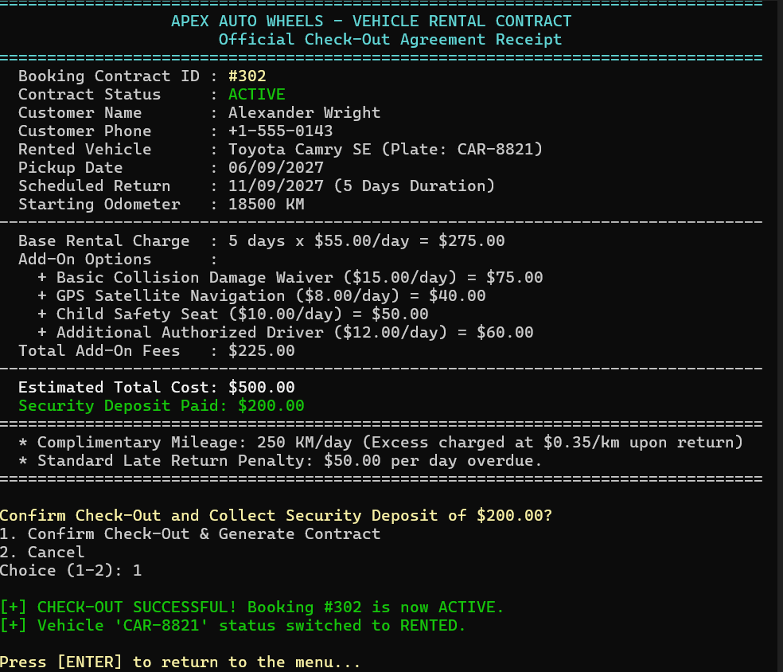

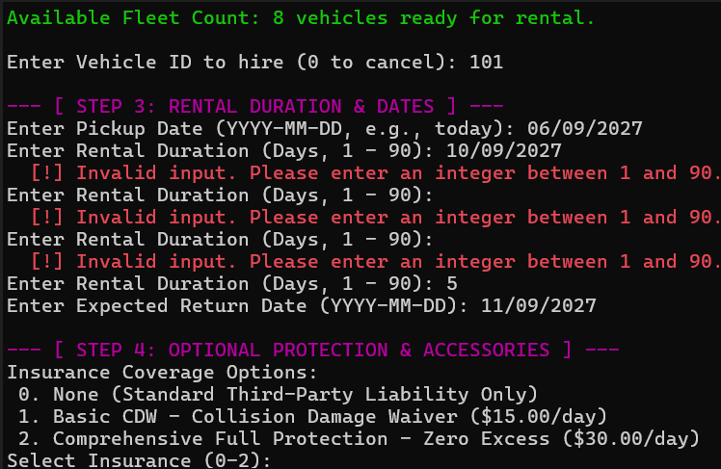

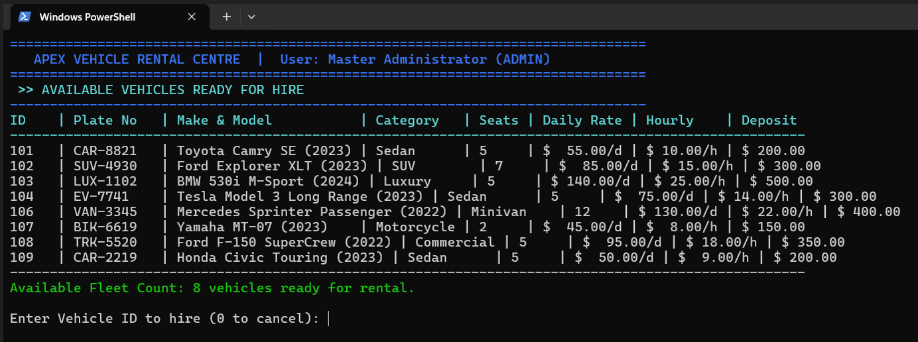

10. One-Page Write-Up: Design Decisions, SDG Relevance & Learning Outcomes

Design decisions
The system separates entities into Customer, Vehicle and Rental structures with Maintenance and Payment nested inside Vehicle and Rental respectively, keeping each struct focused on one concern while still modelling the real dependency between a rental, its vehicle's upkeep, and its payment. A static local counter generates rental IDs so that identifiers stay unique and monotonic without exposing a global variable to the rest of the program. Searching intentionally mixes two strategies: linear search for the frequently-mutated rentals list, where the O(n) scan cost is cheaper than repeatedly re-sorting, and binary search for the more stable vehicle catalogue, where a one-time sort pays for itself over many lookups. Sorting for urgent-request handling uses insertion sort rather than bubble sort or quicksort because it is stable (preserving first-come-first-served order among equal-priority rentals), in-place, and efficient on the small, nearly-sorted arrays this system is expected to hold.

Validation & error handling
Every mutating operation checks its preconditions before touching shared state: addRentalRequest() rejects unknown customer/vehicle IDs and vehicles that are already rented; cancelRental() and updateRental() reject unknown rental IDs; calculateBill() guards against a return deadline entered earlier than the start date by flagging a late fee rather than producing a negative bill. This keeps the fleet-availability matrix and the rentals list consistent with each other at every step, which the test run in Section 8 confirms (the fleet matrix correctly flips a vehicle back to 'available' the instant its rental is cancelled).

SDG relevance
SDG 8 (Decent Work and Economic Growth): the priority-sort and availability-matrix features let a small rental centre schedule staff and vehicles more efficiently, directly supporting better-run local service jobs. SDG 9 (Industry, Innovation and Infrastructure): the project itself is an applied exercise in using structured programming and file-based data processing to build lightweight business infrastructure. SDG 11 (Sustainable Cities and Communities): tracking maintenance dates and return deadlines helps keep rented vehicles roadworthy and available, supporting safer and more reliable local transport. SDG 12 (Responsible Consumption and Production): centralising vehicle, rental and billing records in one persisted store reduces double-booking and untracked usage, cutting the operational waste that comes from paper-based or memory-based record keeping.

Challenges & learning outcomes
The main challenge was keeping three interdependent arrays (customers, vehicles, rentals) consistent through every operation - particularly making sure cancelling or updating a rental correctly flips the linked vehicle's availability flag and the fleet matrix in the same step, rather than leaving stale state that a later search would report incorrectly. Getting the pipe-delimited fscanf() format strings to exactly mirror the fprintf() format on the way back in was a second source of bugs, since a mismatched field width or delimiter silently truncates a record instead of failing loudly. Working through this reinforced why nested structures exist (to avoid duplicating maintenance/payment fields on the wrong entity), why storage class matters even for something as small as a counter, and why the right search or sort algorithm depends on how the data is actually used (read-heavy vs. write-heavy) rather than on which one is asymptotically fastest in isolation.

Individual contribution
I contributed to designing and coding the Vehicle Rental System, including structures, searching, sorting, pointers, and file handling.I tested all major functions such as rental creation, searching, sorting, cancellation, updating, and file saving/loading, and helped prepare the report.

